# 

TECHNICAL PROJECT REPORT

TITLE OF INVENTION / PROJECT: Glowing LED Plate

TEAM MEMBERS / INVENTORS:

|  |  |  |  |  |  |  |  |  |  |  |  |  |  |  |  |  |  |  |
| --- | --- | --- | --- | --- | --- | --- | --- | --- | --- | --- | --- | --- | --- | --- | --- | --- | --- | --- |
|  | **S.** |  |  | **Name** |  |  | **Department** |  |  | **Designation** |  |  | **Mobile** |  |  | **E-Mail** |  |  |
|  | **No.** |  |  |  |  |  |  |  |  |  |  |  |  |
|  |  |  |  |  |  |  |  |  |  |  |  |  |  |  |  |  |  |
|  |  |  |  |  |  |  |  |  |  |  |  |  |  |  |  |  |  |  |
| 1. | |  |  | Satyam Sharma |  |  | ECE |  |  | Student |  |  | 7619979891 |  |  | [Sattysharma119@gmail.com](mailto:Sattysharma119@gmail.com) |  |  |
|  | |  |  |  |  |  |  |  |  |  |  |  |  |  |  |  |  |  |
| 2. | |  |  | Sai Bharghav Reddy |  |  | ECE |  |  | Student |  |  | 6302338180 |  |  | Saibhargav2k27@gmail.com |  |  |
|  | |  |  |  |  |  |  |  |  |  |  |  |  |  |  |  |  |  |
|  | |  |  |  |  |  |  |  |  |  |  |  |  |  |  |  |  |  |
|  | |  |  |  |  |  |  |  |  |  |  |  |  |  |  |  |  |  |
|  | |  |  |  |  |  |  |  |  |  |  |  |  |  |  |  |  |  |
|  | |  |  |  | |  |  | |  |  | |  | |  |  |  | |  |
| 3. | |  |  | Khushal Thakur | |  | ECE | |  | Mentor | | 9646030764 | |  |  | khushal.thakur@cumail.in | |  |
|  | |  |  |  | |  |  | |  |  | |  | |  |  |  | |  |
| 4. | |  |  | Anshul Sharma | |  | ECE | |  | Mentor | | 9478697475 | |  |  | anshulsharma.ece@cumail.in | |  |
|  | |  |  |  | |  |  | |  |  | |  | |  |  |  | |  |
| 5. | |  |  | Kiran Jot Singh | |  | ECE | |  | Mentor | | 9463909689 | |  |  | kiranjotsingh.ece@cumal.in | |  |
|  |  |  |  |  | |  |  |  |  |  |  |  |  |  |  |  |  |  |
| 6. | |  |  | Divneet Singh | |  | ECE | |  | Mentor | | 9878422653 | |  |  | divneet.ece@cumail.in | |  |
|  |  | Kapoor | |  |  |  |  |  |
|  |  |  |  |  |  |  |  |  |  |  |  |  |  |  |  |  |
|  |  |  |  |  |  |  |  |  |  |  |  |  |  |  |  |  |  |  |

***Section – 1 (IPR Related)***

BRIEF ABSTRACT :

This is a name plate with multicolour lightening which consists of on required size acrylic glass sheet fitted in the stand which involve the strip of LED which is of multicolour.

When we write anything with fluorescent pen on the piece of acrylic glass sheet, then after switching ON the LED strip the content or the text will glow continuously, according to the pattern of the multicolour the LED strip

This involves the proper selection of light colour pen and the light of LED strip, without this the colour will collapsed and will not glow on the acrylic sheet so the brightness is also being considered , the level of brightness will be more than the written text will glow to the required level of brightness or otherwise not.

This is the easy creativity that reduces the cost of making banner for shops and other companies

NOVEL/ADDITIONAL MODIFICATIONS THAT YOU CAN PROPOSE TO IMPROVE UPON DRAWBACKS

1. *It will reduce the cost of making banner as the owner changes the frequently.*
2. *It is rewritable and reliable*

ADVANTAGES

1. It creates interest among the children in playschool.

BLOCK DIAGRAM

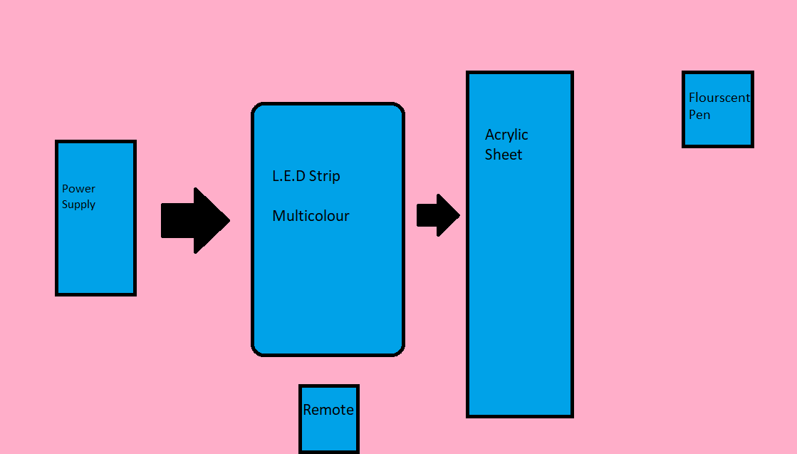

***Section – 2 (Real Project)***

MATERIALS

1. L.E.D Strip of 1 meter which costs Rs.72
2. Acrylic Sheet which costs Rs.200
3. Stand

Overview

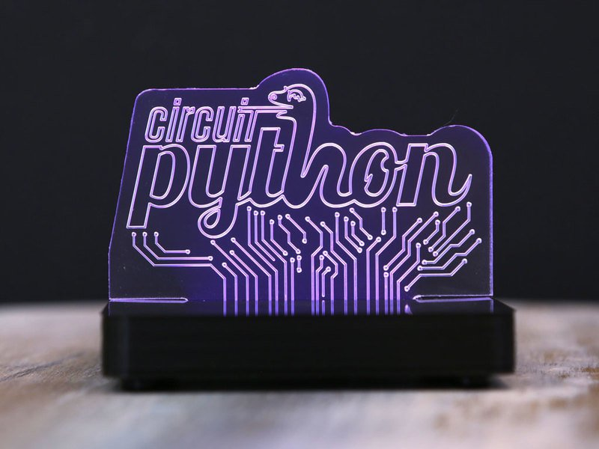

Step Of Completion

1. Firstly we bought all the items like LED strip Acrylic sheet and stand.
2. Then We Ordered Fluorescent Pen.
3. After that we analyse the whole circuit and made a rough diagram.
4. Then we initiated the work and made the model.
5. At last the model successfully worked.

**BEEE LAB**